Week 9
write a program to create a simple calculator application using react.js
npx create-react-app calculator
cd calculator
npm start

app.js
import React, { useState } from "react";
import "./App.css";

function App() {
const [input, setInput] = useState("");

// Function to handle button click
const handleClick = (value) => {
setInput(input + value);
};

// Function to clear the input
const handleClear = () => {
setInput("");
};

// Function to calculate the result
const handleCalculate = () => {
try {
// eslint-disable-next-line no-eval
setInput(eval(input).toString());
} catch (error) {
setInput("Error");
}
};

return (
<div className="calculator">
<h1>React Calculator</h1>
<input type="text" value={input} readOnly />

<div className="buttons">
<button onClick={handleClear}>C</button>
<button onClick={() => handleClick("/")}>/</button>
<button onClick={() => handleClick("*")}>*</button>
<button onClick={() => handleClick("-")}>-</button>

<button onClick={() => handleClick("7")}>7</button>
<button onClick={() => handleClick("8")}>8</button>
<button onClick={() => handleClick("9")}>9</button>
<button onClick={() => handleClick("+")}>+</button>

<button onClick={() => handleClick("4")}>4</button>
<button onClick={() => handleClick("5")}>5</button>
<button onClick={() => handleClick("6")}>6</button>
<button onClick={handleCalculate}>=</button>

<button onClick={() => handleClick("1")}>1</button>
<button onClick={() => handleClick("2")}>2</button>
<button onClick={() => handleClick("3")}>3</button>
<button onClick={() => handleClick("0")}>0</button>

<button onClick={() => handleClick(".")}>.</button>
</div>
</div>
);
}

export default App;

app.css
body {
background-color: #f2f2f2;
font-family: Arial, sans-serif;
text-align: center;
padding: 30px;
}

.calculator {
background: white;
width: 260px;
margin: auto;
border-radius: 15px;
box-shadow: 0px 0px 10px gray;
padding: 20px;
}

input {
width: 220px;
height: 40px;
font-size: 20px;
margin-bottom: 15px;
text-align: right;
padding: 5px;
}

.buttons {
display: grid;
grid-template-columns: repeat(4, 1fr);
gap: 10px;
}

button {
height: 50px;
font-size: 18px;
border: none;
border-radius: 10px;
background-color: #007bff;
color: white;
cursor: pointer;
transition: 0.3s;
}

button:hover {
background-color: #0056b3;
}

h1 {
margin-bottom: 15px;
}

Run the Application

npm start

output
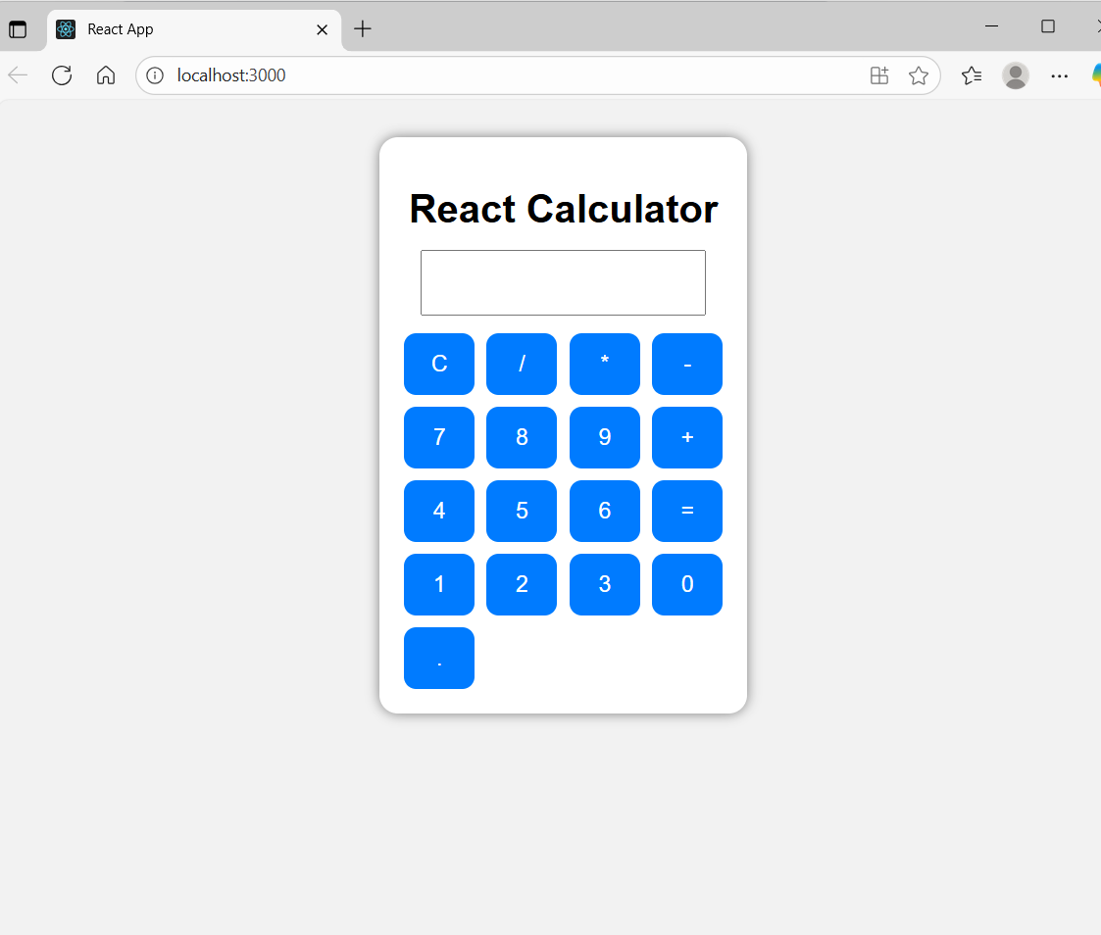

- React → enables you to create components and JSX elements.
- useState → a React Hook that allows us to manage component data (state).
- "./App.css" → imports the CSS file for styling.
- function App() { (Defines a functional component named App.
In React, the App component is the root component of application.)
const [input, setInput] = useState("");
- input → stores the current input value displayed on the calculator screen.
- setInput → a function used to update that state.
- Initially, input is an empty string ("").
const handleClick = (value) => {
setInput(input + value);
};

This runs when a number or operator button is clicked.
It concatenates the button value (value) to the current input string.
Example:
If input = "1" and user clicks +,
then setInput("1" + "+") → input becomes "1+".
const handleClear = () => {
setInput("");
};

Resets the calculator by setting input back to an empty string.
This is triggered when user clicks C (clear).

handleCalculate() function
- This function is triggered when user presses the = button.
- It uses JavaScript’s eval() to evaluate the string expression.
- Example: if input = "5+3*2", eval("5+3*2") = 11
- If any error occurs (like typing invalid input), it shows "Error".

VIVA Questions

- What is React?
- What is the purpose of useState in React?
- What is the role of eval() in this program?
- What does readOnly do in the input element?
- What happens when we click a button?
- What is the difference between class and className in React?
- Why do we import "./App.css"?
- What is Hooks in react
- What is JSX?
- Can you use multiple states in a single component?

